Project 4: Storyboard
Tikondane PayPal Training Design Document
Leyna Bencomo & Anne Elias | 4-06-2017

Instructional Design & Planning | INTE 5100

Storyboard Overview

The Tikondane Community Centre in Katete, Zambia is getting a welcome hand in increasing donations by learning to upgrade their website with PayPal.
This storyboard will focus primarily on the first objective of our training. We want our learner to be able to demonstrate his understanding of the steps involved with signing up for a PayPal account.
To do this, we must first show him in careful detail exactly how to complete this task successfully. The main teaching tool in this section of the training will be a video tutorial (using both still frame images and recorded screencast), which will start with an introduction to PayPal as a tool and then progressively illustrate new account setup. The video will include English captions of voiceover narration, light music, still frame graphics emphasizing important points
Secondary tools will involve an physical flowcharting activity described in the Practice Opportunity section (to check understanding and serve as a visual aid) with emailed instructions from the designers. The pieces representing steps will be easy-to-handle, magnetic tiles that can be put onto a slate with the flowchart imprinted on it. We will also include some blank puzzle tiles so that the assessment can be made more difficult by leaving a printed piece out.
We have made the following determinations about our learner prior to designing this objective:
- Musa (primary learner) is comfortable using a computer & peripherals, the internet and minimal typing
- Learner has a physical disability which necessitates designing for his abilities
- Learner has an email account associated with the Tikondane Community Centre
- Learner has a mentor (Catherine) who will evaluate his progress with the lesson, assess his understanding and provide feedback to the learner and to designers.

Title of Learning Solution | Adding PayPal Payment Method to the Tiko Website
Target Audience | Primary learner: Musa (an intern at Tikondane)  Secondary learner: Catherine (his mentor)
Description of Learning Solution | Learning solution will utilize a combination of online video tutorials, analog materials (flowchart & pieces), in person assessment and email correspondence to address one learning objective:  After reviewing a brief video tutorial via Youtube, the learner will list the steps showing how to open a PayPal account by filling in a visual aid flowchart template. The actual answers will be provided in stickers to be chosen and placed onto the flowchart in the correct sequence. This format is being used to accommodate Musa’s physical difficulty with writing.
Materials Required | - Computer with internet access. Bandwidth suitable for streaming video.  - URL to video tutorial  - Headphones/mic  - Email account  - Learning packet sent by mail: flowchart kit, labels and written instruction  - Note taking tools (pen/pencil)
Duration of Entire Learning Solution | 30 minutes

Alignment

Alignment for this part of the training will focus on successful completion of the first learning objective stated in the design document (and highlighted below). Completion of this goal necessitates the ability to watch and follow a brief video tutorial, demonstrate understanding of the steps through a followup flowcharting activity and in-person evaluation. While the Practice Opportunity for this objective is paper-based (in this case, a physical magnetic tile game), it will allow our learner to test his skills before committing to the online component, create a long-lasting visual aid which will be used to complete the largely internet-based training and finally to reflect on what he has learned.

Overall Project Learning Objectives

- After reviewing a brief video tutorial list the steps showing how to open a PayPal account by filling in a visual aid flowchart template. The actual answers will be provided in tiles to be chosen and placed onto the flowchart in the correct sequence. This format is being used to accommodate Musa’s physical difficulty with writing.
- Using the information outlined in the previously completed flowchart activity, the student will create (build) a functioning PayPal account for the Tikondane center.
- After completing a brief video tutorial on adding a link to their website, the learner will demonstrate the process to their mentor by successfully linking the new PayPal account to the Tikondane Donate Now webpage.
- After embedding PayPal link, the learner will be able to verify that the links work successfully navigating to the URL and filling out the appropriate fields.
- After successful completion of each activity, the learner will be able to reflect on the

Storyboard  Learning Objective(s) | Learning Objective 1  The learner will be able to demonstrate understanding by listing the steps needed to set up a PayPal account on the Tiko website.
Instructional Approach | Our instructional approach includes both technology and manual manipulatives.  Learner will stream a video tutorial on YouTube which will show the steps necessary to set up a PayPal account.  Learner will take notes and repeat the video as much as he deems necessary in order to understand the steps.
Practice Opportunity | Learner will be given a blank flowchart and magnetic tiles representing each step. He will be shown how to put the tiles into the correct sequence on the flowchart which mirrors the online process of opening a PayPal account.  He will then have the opportunity to try this activity himself with the tiles mixed up.  Extra tiles will be added with steps that don’t belong in the flowchart to make the activity increasingly difficult and to provide friction in his learning. Dirksen explains that adding friction will likely increase the learner’s retention.  If more difficulty is needed, a blank tile can be substituted for one of the steps to see if he can recall which step is missing.  Note: The completed flowchart can be used as tool for successful completion of all subsequent objectives.
Assessment Item | Assessment completed in person by mentor.  She will empty the flowchart and give him a selection of tiles to see if he can correctly fill out the flowchart, demonstrating his knowledge of the steps needed to add a PayPal account to a website.  Note: After the assessment, follow up discussion on results with designers (via email) as necessary for instructional adjustment, questions or comments.

Module 1: Streaming Video

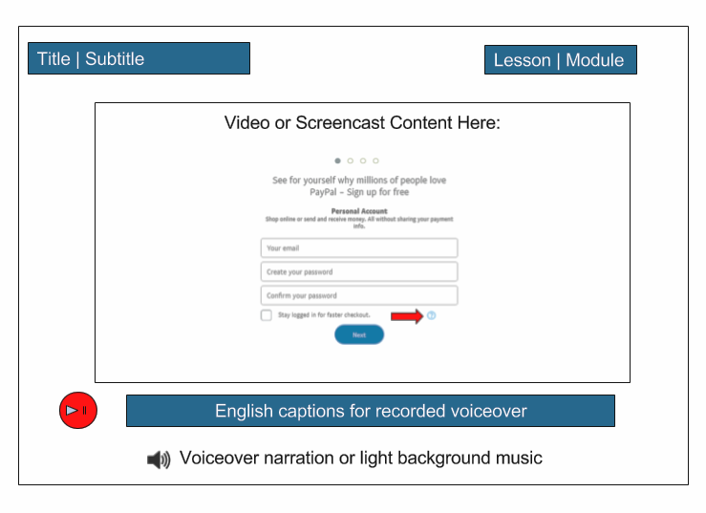

Module # | 1 | Module Title | PayPal Account Creation
Screen # | 1.1 | Lesson Title | Why Use PayPal?: Intro to this tool
Objective |  | To introduce our learner to the topic (what he will be learning and why) and to give him more information about his learning solution and involved parties.

Text |  | Graphics
No text |  | This will be a narrated intro section with one of the designers (or the developer) talking directly to the camera.
Sample Script: |  | “Hello and welcome to your first video tutorial! You will be learning about using PayPal because it is a secure and customer-friendly way for visitors to make payments and donations to the Tikondane Community Centre and non-profit organization. Follow the video in sequence, take notes as you go and feel free to email us with any questions. After the video, you will complete a graphic activity and will be evaluated by your mentor. Good luck and have fun!”
Sound |  | Light intro music and recorded narrative voiceover
Notes to Developer | Our primary learner has a disability which affects his ability to type. Any curriculum design must take this into account and minimize the amount of keystrokes needed. If the curriculum is navigable using a mouse and/or dictation software, it is useable by our primary learner.

Module # | 1 | Module Title | PayPal Account Creation
Screen # | 1.2 | Lesson Title | Setting up a PayPal account: The Basics
Objective |  | Learner will follow video tutorial showing how to navigate to the PayPal account creation url (via video tutorial). Learner should take notes while interacting with video.

Text | Graphics
Screen will display introductory slide (with image), instructions, learning objective and designer contact information  Captions for any recorded narration | Opening slide showing image of Tikondane Welcome Centre  Screencast format.
Sound | Light intro music and recorded narrative voiceover

Module # | 1 | Module Title | PayPal Account Introduction & Creation
Screen # | 1.3 | Lesson Title | Directing browser to the PayPal account URL:  https://www.PayPal.com/us/signup/account/personal
Objective |  | Follow video tutorial showing how to navigate to the PayPal account creation url (via video tutorial)

Text | Graphics
Video will be accompanied by captions (English)  Video screencast/instructional video of steps to open PayPal Account including:  - Navigating to URL  https://www.PayPal.com/us/signup/account/personal | Video in screencast or still image format. Learner will see where to enter URL into browser in order to navigate to new account sign up page.
Sound | Video accompanied by recorded voiceover narrative

Module # | 1 | Module Title | PayPal Account Introduction & Creation
Screen # | 1.4 | Lesson Title | Entering Your Personal Information
Objective |  | Follow video tutorial showing how to navigate to the PayPal account creation url (via video tutorial)

Text | Graphics
Video will be accompanied by captions (English)  Intro slide may include instructional text and contact information for help.  Video screencast/instructional video of steps to open PayPal Account including:  - Inputting personal information  - Using the helpful hints icon (see graphic)  - Clicking submit/complete to finalize account creation  - Checking user email to verify account creation with secure link provided by PayPal | This section of the video will display the main sign up page (including PayPal logo).  Graphics include fields for filling in personal information:  Name  Company affiliation  Contact Information  Credit Card/Bank Account information  Using helpful hints to answer questions on page (see below)  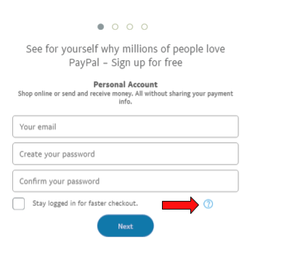
Sound | Recorded voiceover narration

Module 2: Practice Opportunity

Our Learner will have ample opportunity to practice the steps he learned on the video in the first module. Our manipulative consists of a slate with a blank flowchart of steps to create a PayPal account and some individual magnetic tiles that represent the different steps that can be placed into the flow chart.

This Practice Opportunity can be used in various ways depending on how the learner and his mentor determine is best. The tiles will closely represent the steps that were presented on the video.

Here is an example of what the blank Flowchart should look like:
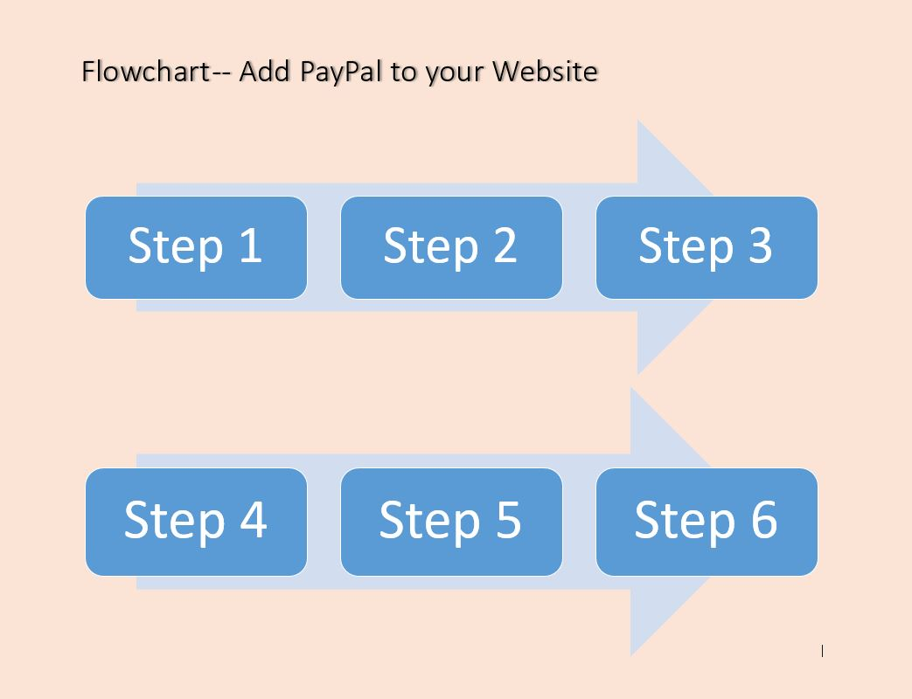

Here is an example of what a partially filled flowchart should look like:
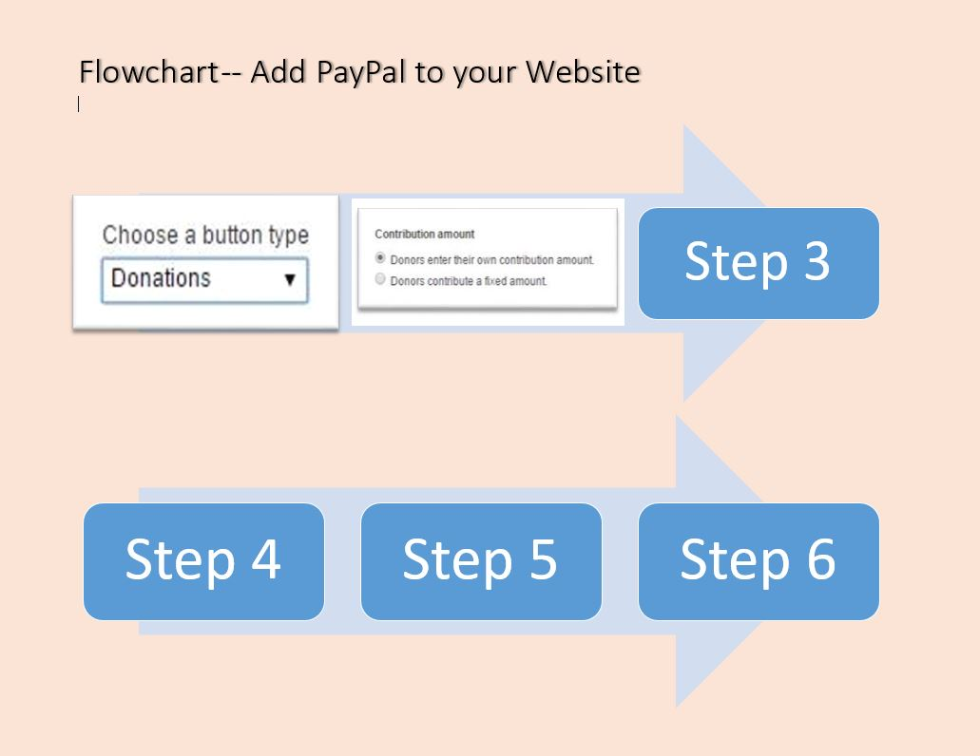

After some discussion, we have determined that it would be best to create a more permanent solution in a small, sturdy magnetic board rather than a paper solution. We wanted to ensure that the learner would use this tool for his future learning objectives and also could potentially post this for future reference. This board could also be altered in the future by removing the tiles and replacing them as needed if the PayPal process changes. We, as designers also felt that this slate might be more easily managed by our primary learner with his physical challenges.

Another reason for the slate and tile design is the fact that it may represent more of a game for the learner. Applying creativity to this portion of the design is more of a whole pie approach as suggested by Bean in her book, The Accidental Instructional Designer.

Here are some examples of the magnetic tiles that would be placed in the flowchart during the practice opportunity:

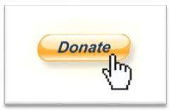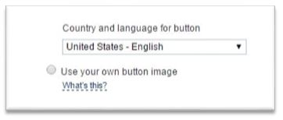
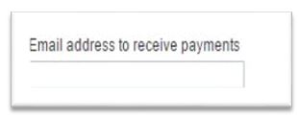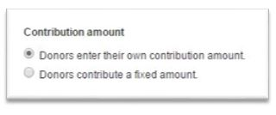
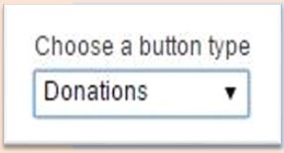

Practice Type Option 1
Learner will be given the flowchart with the six tiles placed correctly. He will review the tiles and relate them back to his notes from the video and state the steps aloud.

Practice Type Option 2
Learner will be given the blank flowchart and the six tiles that would complete the flowchart correctly. Learner will fill out the flowchart with the six tiles in the correct sequence.

Practice Type Option 3
Learner will be given the blank flowchart and eight tiles and must choose the correct six tiles placing them in the correct sequence on the flowchart.

Practice Type Option 4
Learner will be given the blank flowchart and five correct tiles and a blank tile and will place the five tiles in the correct sequence and put the blank tile in the correct missing step and tell the tutor what it should represent.

We expect that the tutor and learner will come up with more ways to use this practice tool and we will provide them with several blank tiles for potential future use.

Assessment

The final assessment for this objective will use the manipulatives introduced in the Practice Opportunity section of this storyboard. Assessment for this specific objective will not involve technological tools. Our learner is partnered with his mentor, Catherine. She is motivated to train Musa in order to transition him to working in the office in a more assistive capacity. Therefore overall assessment will be based on several key components.

Mentor Evaluation
Catherine will monitor several key points of this learning solution:
- Completion of video within the week 5 of the project
- Completion of Practice Opportunity within week 5 of the project
- Assess learner’s subject mastery through accuracy of Practice Opportunity
- Application of knowledge to learning objectives 2-5
Given the versatility built into flowcharting activity, Catherine can alter the difficulty level of the practice sessions as needed by the learner. If she is noticing a high frustration rate with our learner, she can simplify them and slow the progress. If he is a quick study, she can skip the simple practice options and move on to more difficult ones. Catherine will serve as the point person for communication with the project designers about the usefulness of the practice tool.

To assure that Musa has retained the step by step information on the flowchart, Catherine will empty the flowchart and ask Musa to recite the steps in sequence with no help from the tiles. As he recites each step, she will place the correct tile in place as a memory aid for the next step. She will be able to determine how many steps he was able to state with no help from the tiles and report these findings. The assessment can be repeated for a better score.

Learner Self-Reflection

The assessment will end with Musa reflecting on what he has learned via email correspondence with the designers.

Sample reflection questions:

- What did you find most challenging about this portion of the learning solution?
- On a scale of 1-5, how prepared do you feel to move on to the next objective?
- How will you plan to use the visual aid you created?
- Are there any changes you would like to see in future activities?

The following flowchart shows the flow of information, content, activity, assessment and reflection using the first learning objective as an example: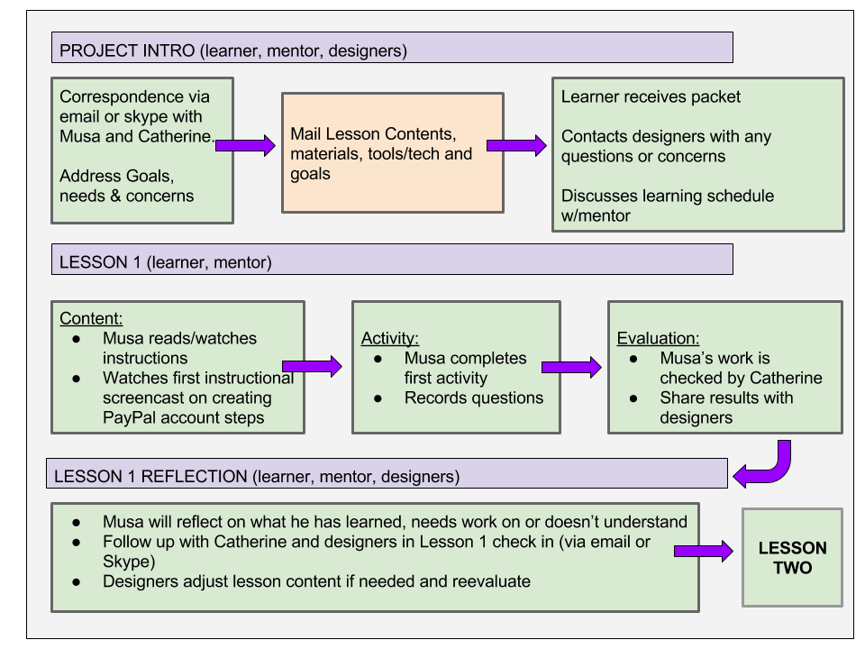

References

Bean, C. (2014). The Accidental Instructional Designer. Alexandria, VA: American Society for Training and Development.

Dirksen, J. (2016). Design for how people learn. Berkeley, CA: New Riders.

